**Group 4 Project: Carfax**

**Team Members:** David Obembe, John Dilligard and Christion Lankford

1. **Objective**

The goal of our project is to use our newly learnt skills in extraction, transformation and loading of data — to migrate information on pre-qualified “Jeep Cherokee” SUV’s into a database hosted on Google cloud.

1. **Data Sources**

* Carfax.com
* Carmax.com

1. **Database Design**

The database will consist of 5 tables, each containing information on the cars description, price, drivetrain, mileage, and dealer’s respectively.

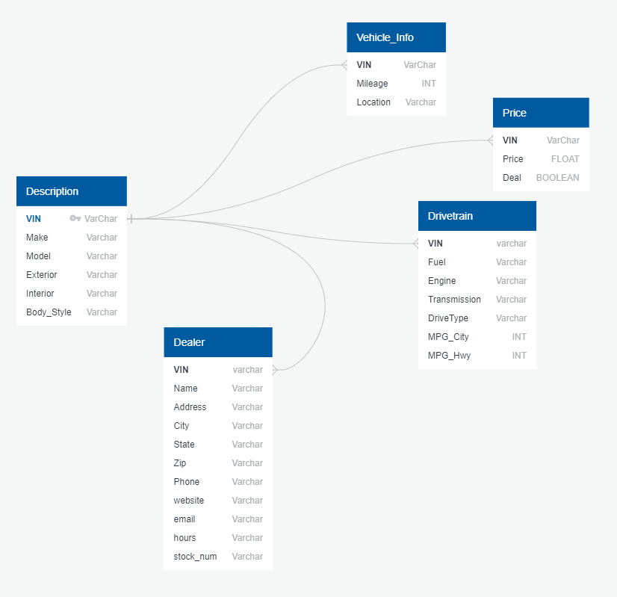

**Fig.1:** ERD diagram of database

1. **Type of Database**

The database should be a non-relational MongoDB database. We chose this due to its flexibility as well as due to the possibilities of finding car data that may lack information in certain fields/columns.